EXPERIMENT 6:

Write R program to perform matrix addition

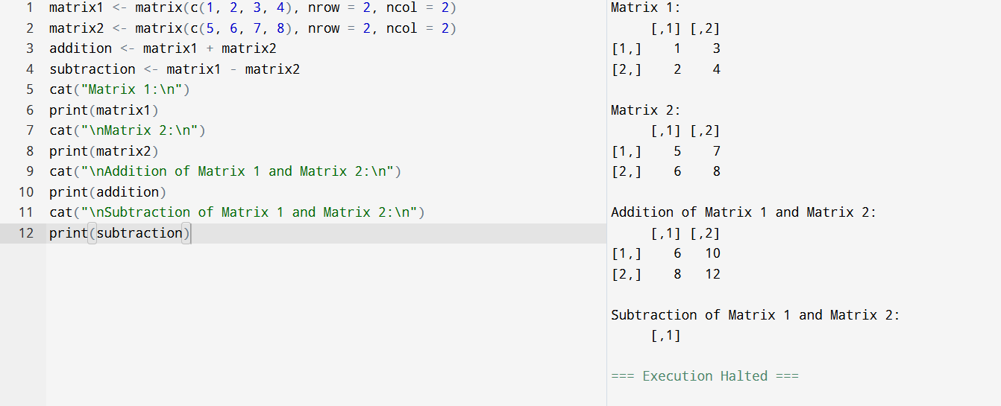

EXPERIMENT 7:

Write R program to perform matrix multiplication

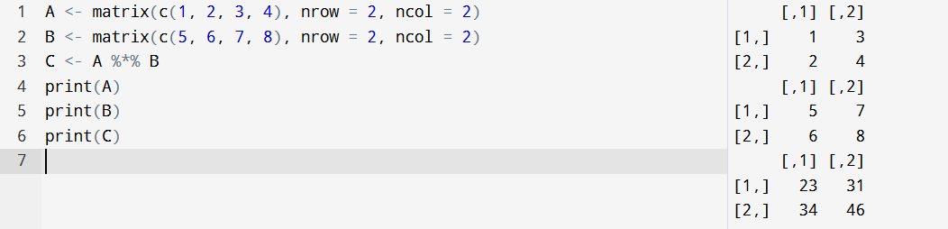

EXPERIMENT 8:

Write R program to take input from user (name and age) and display the values. Also print the version of R installation.

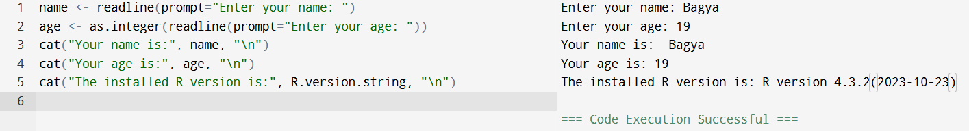

EXPERIMENT 9:

Write R program to get the details of the object in memory.

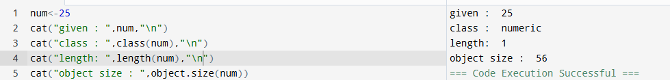

EXPERIMENT 10:

Write R program to create a sequence of numbers from 20 to 50 and find the mean of numbers from 20 to 50 and sum of numbers from 51 to 91.

